CS639 – Final Practice Questions

Instructions:
- These questions are similar to those in the final exam.
- This document is not representative of the length of the final (it’s too long).
- Go back and study the material that is associated with each of the practice questions.
- For additional exam-samples please take a look here: http://www.ds100.org/sp19/resources

Data Generation and Probability Samples

For each of the following questions select the single best answer.

1. A political scientist is interested in answering a question about a country composed of three states with exactly 10000, 20000, and 30000 voting adults. To answer this question, a political survey is administered by randomly sampling 25, 50, and 75 voting adults from each town, respectively. Which sampling plan was used in the survey?

- Cluster sampling
- Stratified Sampling
- Quota sampling
- Snowball sampling

2. A deck with 26 cards labeled A through Z is thoroughly shuffled, and the value of the third card in the deck is recorded. What is the probability that we observe the letter C on the third card?
- 1/26
- 3/26
- (25/26) * (24/26) * (1/26)
- None of the above.

3. Suppose Iris visits your store to buy some items. She buys toothpaste for $2.00 with probability 0.5. She buys a toothbrush for $1.00 with probability 0.1. Let the random variable X be the total amount Sam spends. What is E[X]? Show your work in the space provided.

- $1.10
- $1.5
- $3.00
- The toothpaste purchase may not be independent of the toothbrush purchase so we cannot compute this expectation.

4. Suppose we have a coin that lands heads 80% of the time. Let the random variable X be the proportion of times the coin lands tails out of 100 flips. What is Var[X]? You must show your work in the space provided.

- 0.8
- 0.16
- 0.04
- 0.0016
- 0.008

Hypothesis Testing

A mysterious undergraduate stops you on your way to class and claims that they have learned to flip any coin such that it lands on heads more often than the 50% you’d expect from random chance. To demonstrate, they takes a penny from their wallet, flip it 10 times, and get heads nine times and only gets tails once.
- The null hypothesis is that this was pure random chance, and that the probability of getting heads was 50% for each flip. What is the p-value under the null hypothesis of getting 1 or fewer tails out of 10 flips?

- Suppose the undergraduate flips the coin 28 more times, and they all end up heads. The resulting p value including all 38 flips under the null hypothesis is approximately p_{b} = 10⁻¹⁰. Which of the following are true? Select all that apply,

  - It is extremely unlikely that the undergraduate just happened to get 37 heads by randomly getting heads on 50/50 coin flips.
  - p_{b} is the probability that the null hypothesis is true.
  - 1 - p_{b} is the probability that the undergraduate has the skill to flip any arbitrary coin and get heads.
  - If you flipped a fair coin 38 times, p_{b} is the chance that you’d get at least 37 heads by random chance.
  - The undergraduate has proven beyond any reasonable doubt that she has the skill to flip any coin to land on heads with high probability.
  - None of the above.

Classification

- Suppose we train a binary classifier on some dataset. Suppose y is the set of true labels, and yˆ is the set of predicted labels.

Determine each of the following quantities
- The number of true positives

- The number of false negatives

- The precision of our classifier. Write your answer in a simplified fraction.

- You have a classification data set, where x is some value and y is the label for that value:
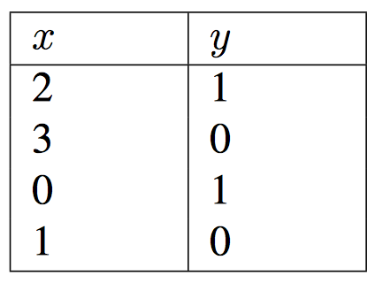
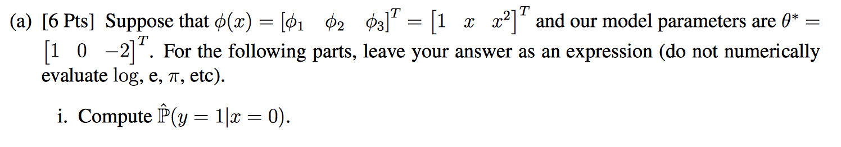

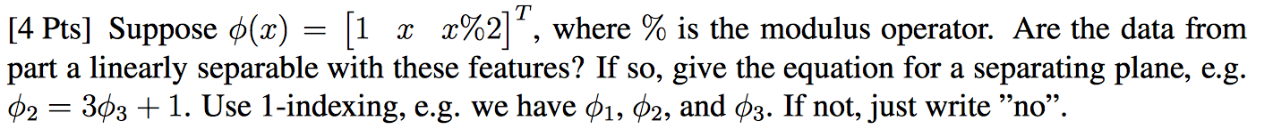

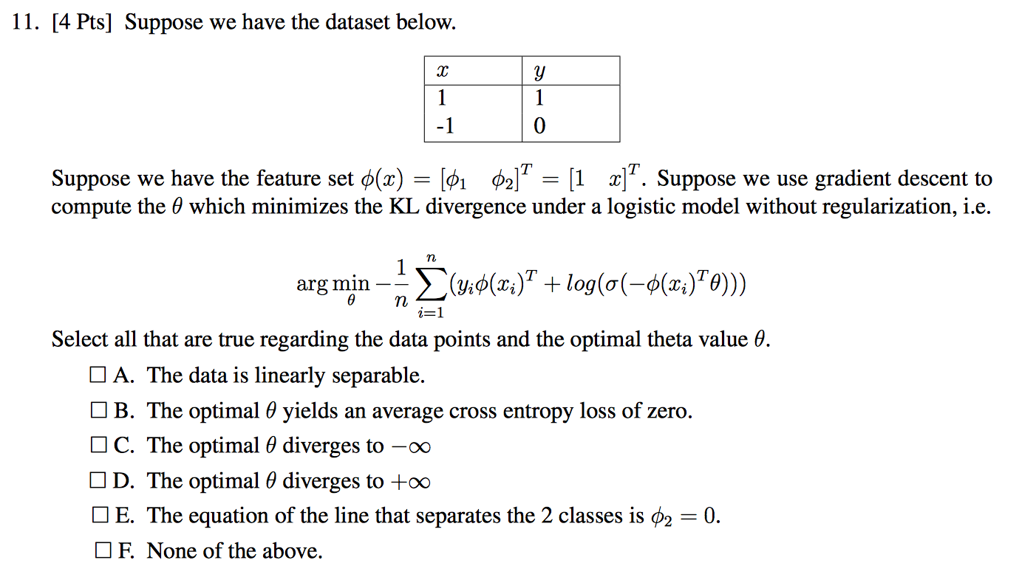

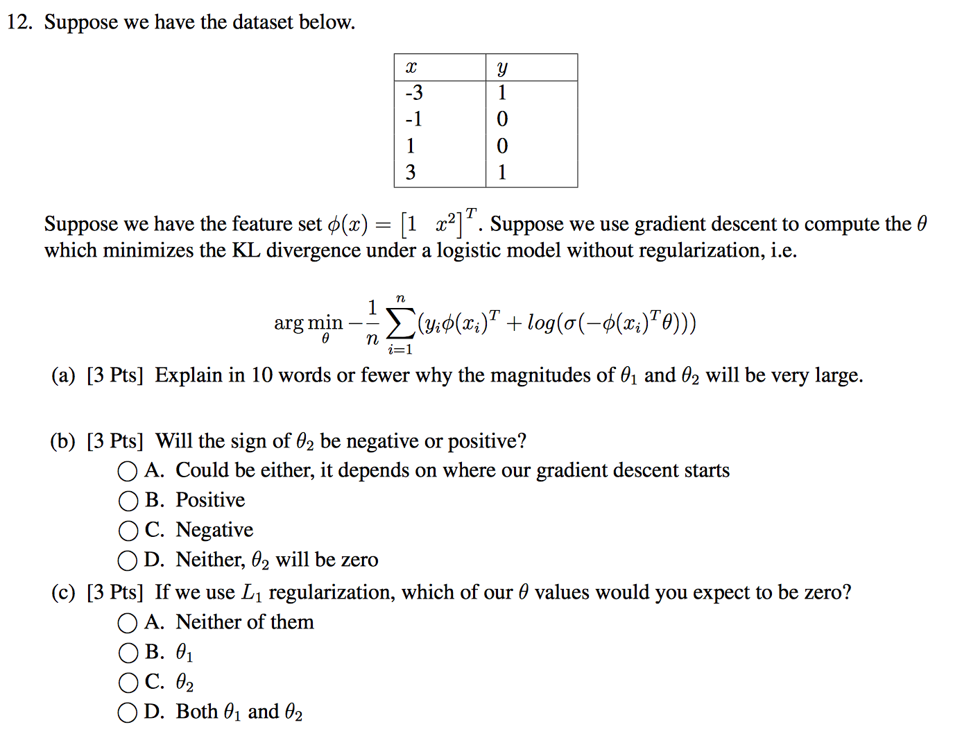

Bias and Variance Trade-off
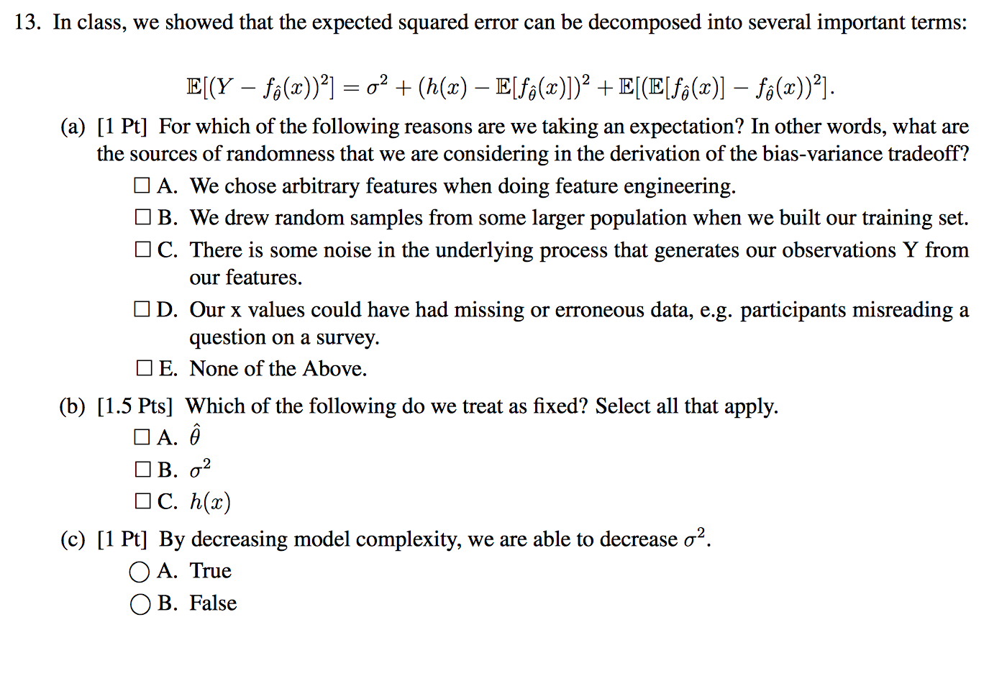
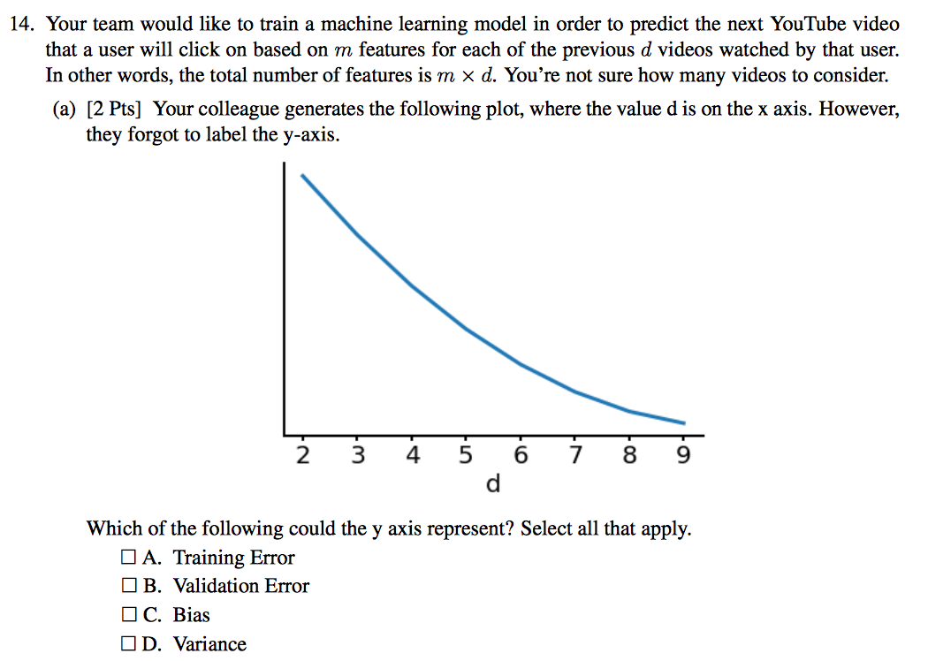
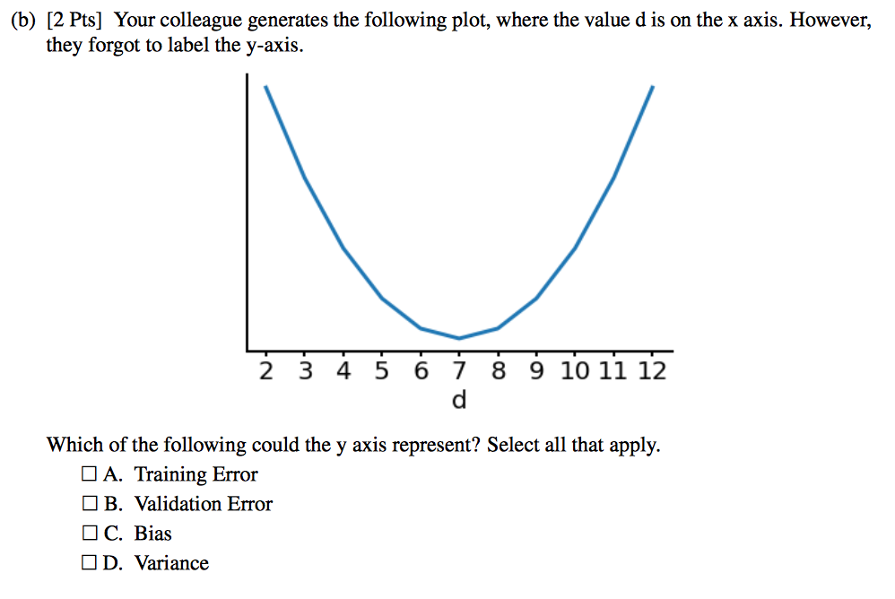

Linear Models
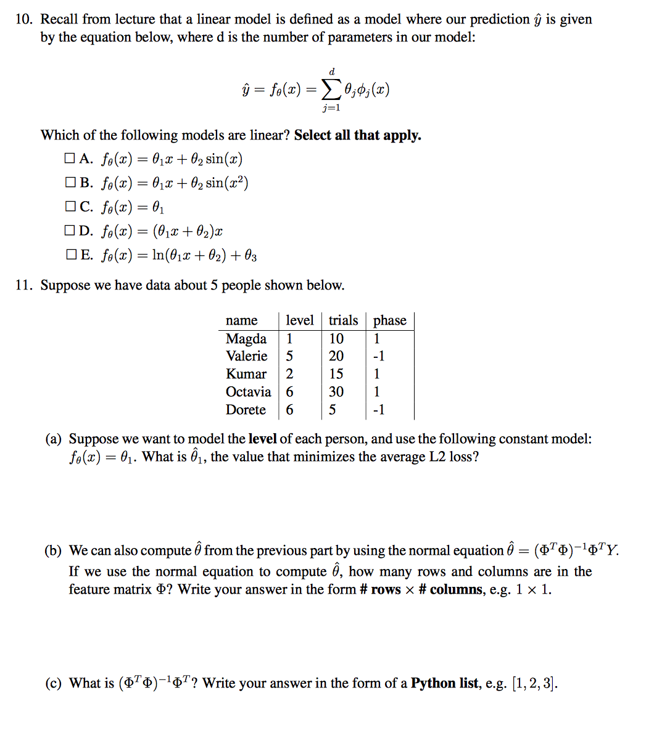

Gradient Descent
